Zokforce Insights - The New Era of AI Transformation

Executive Summary

In the current digital era, Artificial Intelligence (AI) is a core driver of corporate development. However, a significant paradox has emerged: while
78% of global enterprises have adopted AI in some capacity, a mere 25% of AI projects achieve their expected ROI. This gap highlights that successful AI transformation is not a technical challenge but a strategic one, requiring systematic engineering and a focus on long-term value.
This report, based on research from over 500 global enterprises, diagnoses this value gap, identifies the seven core challenges hindering progress, and presents Zokforce's proprietary frameworks to guide a successful transformation. We introduce:
- The Four-Quadrant AI Maturity Model to help enterprises identify their current state.
- The Three-Stage Transformation Path to provide a clear, value-driven roadmap.
- The Eight Core Indicators that enterprises must prioritize for successful AI agent deployment.
Our analysis shows that by shifting focus from pure technical deployment to systematic value creation, enterprises can bridge the ROI gap and build sustainable competitive advantages

The Core Problem: A Global AI Value Gap
The global AI landscape is defined by a deep contradiction: soaring adoption rates paired with disappointing value realization. This "adoption rate paradox" is the central challenge facing enterprises today.

High Adoption, Low Return

Global enterprise AI adoption reached a remarkable
78% in 2025, up from 72% in 2024. Furthermore,
92% of companies plan to increase their AI investment in the next three years, signaling strong market confidence.
However, the reality of value creation is starkly different: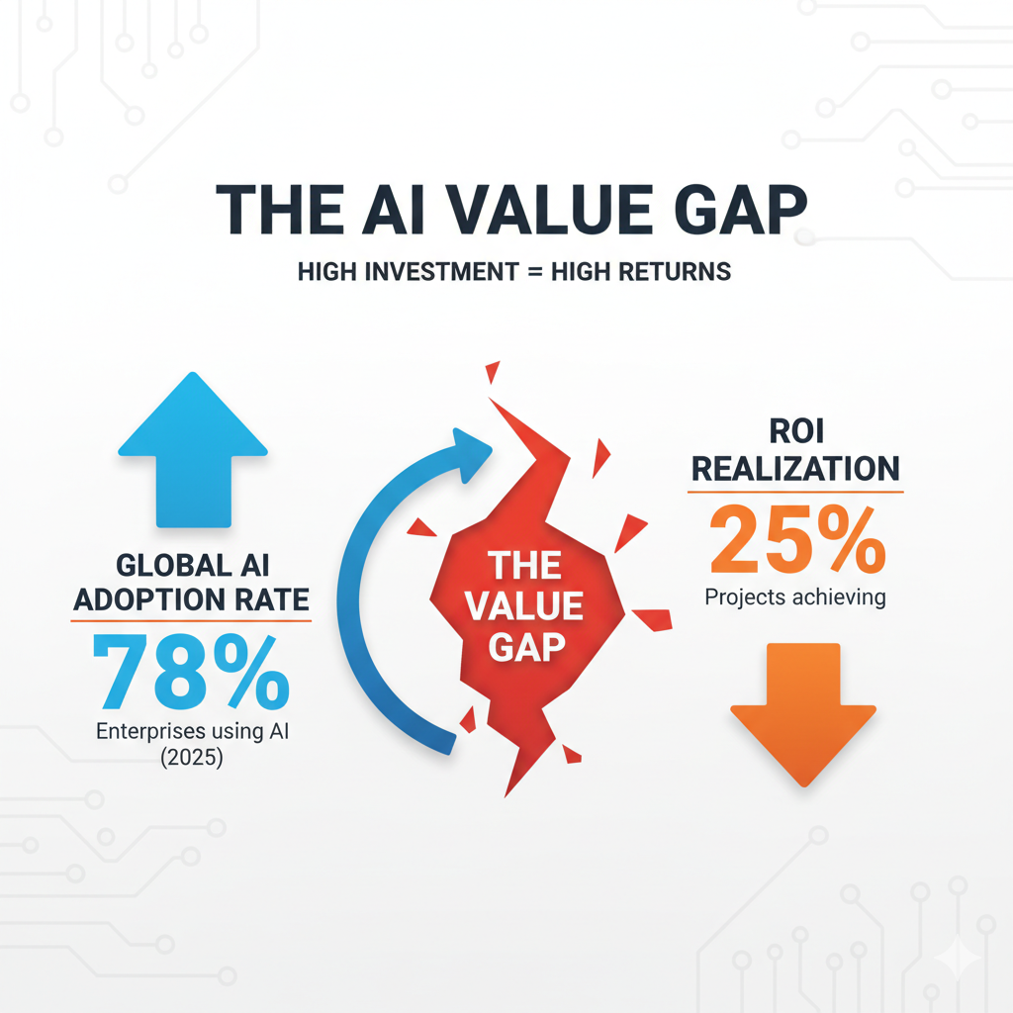
- 25% of AI projects meet their expected ROI.
- 74% of companies have not yet seen scalable, tangible value from their AI investments.
- Only 1% of executives believe their AI plans have reached maturity.
This discrepancy is explained by the difference between adoption and deployment. The 78% "adoption rate" refers to using AI in at least one function (e.g., using ChatGPT for emails), while "active deployment" means integrating AI into core business processes. Most enterprises remain at a surface-level application stage, which is why value remains elusive.

Regional Deployment Differences
When looking at active deployment, the global picture is highly varied. Emerging markets are often outpacing mature ones in their willingness to integrate AI deeply.
- Leading Nations: India (59%), the UAE (58%), and Singapore (53%) are leading the world in active AI deployment.
- The US Paradox: Surprisingly, the United States, a birthplace of AI, ranks 9th with a deployment rate of only 33%. This reflects that the origin of a technology does not guarantee its widest application.

The Root Cause: Top 7 AI Transformation Challenges
Our research shows that the value gap is caused by a consistent set of challenges that hinder progress from pilot stages to full-scale integration.
- Skills Gap (87%): The most significant barrier is the lack of talent, not just in technical roles but also among business personnel who need to manage AI applications.
- Data Quality Issues (64%): Poor data quality remains a primary obstacle, as 77% of enterprises admit their data quality is average or worse, directly impacting model accuracy.
- Cost Control Difficulty (52%): AI projects frequently exceed budgets due to hidden costs in computing power, talent, and ongoing maintenance.
- Technical Integration Complexity (48%): Integrating new AI systems with legacy enterprise architecture is a major technical hurdle.
- Governance Framework Gaps (41%): A lack of clear governance leads to compliance risks and slows down innovation.
- Change Management Resistance (38%): Organizational resistance to new workflows and processes can stall AI initiatives.
- ROI Measurement Difficulty (35%): Many companies struggle to establish clear metrics to quantify the business value and ROI of their AI projects

The Zokforce Solution: A Three-Step Framework for Value Creation
Overcoming these challenges requires a systematic approach. Zokforce has developed a comprehensive framework to guide enterprises from their initial exploratory steps to industry leadership.

Step 1: Assess Your Maturity - The Four-Quadrant Model
Enterprises fall into one of four categories based on their AI capability maturity and the business value they've realized. Understanding your position is the first step toward a targeted strategy.
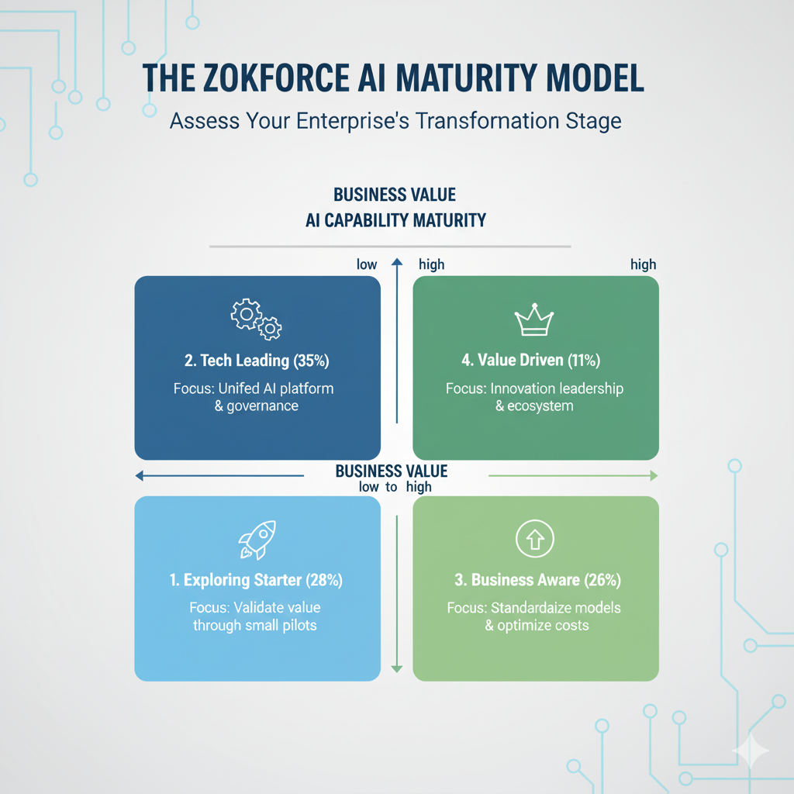
- Exploring Starter (28%): In the initial stages, with a willingness to innovate but little experience.
Focus: Validating value through small-scale, risk-controlled pilots.
- Tech Leading (35%): Possess strong technical skills but suffer from siloed AI systems that don't generate synergistic value.
Focus: Creating a unified AI platform and governance framework to integrate efforts.
- Business Aware (26%): Have successfully integrated AI into specific business units but struggle with scaling these successes cost-effectively.
Focus: Standardizing successful models and optimizing cost-benefit to enable replication.
- Value Driven (11%): The most mature group, using AI as a core competitive advantage and exporting capabilities.
Focus: Maintaining innovation leadership and building an open partner ecosystem.

Step 2: Define Your Priorities - The Eight Core Indicators
Based on our survey of 500+ enterprises, we identified the eight most critical factors when selecting and deploying AI Agents. These should guide your development and procurement decisions.
Foundational Capabilities:
- Response Accuracy (86%): The top priority. The goal has shifted from "can it answer?" to "can it answer correctly?".
- Processing Speed (78%): Milliseconds matter. For every 100ms reduction in response time, user conversion rates increase by an average of 1.2%.
- Data Security (75%): This is the foundation of commercial trust and can command a 15-25% pricing premium in B2B markets.
Governance & Trust:
- AI Ethics Compliance (69%): No longer just a risk management tool but a value creator, with strong governance linked to 30% higher ROI.
- Governance Transparency (61%): Essential for solving the "black box" problem, especially in regulated industries like finance and healthcare.
Advanced Integration:
- Multi-modal Coordination (64%): AI that fuses text, voice, and images provides a richer user experience and 40% higher user satisfaction.
- System Integration (58%): Ensures AI can connect seamlessly with existing enterprise systems for end-to-end value.
Task Execution Completeness (52%):
- Measures the AI's ability to see complex, multi-step tasks through to completion.

Step 3: Follow the Path - The Three-Stage Transformation Journey
Zokforce has designed a proven, three-stage path for systematic evolution, balancing value, risk, and sustainability.
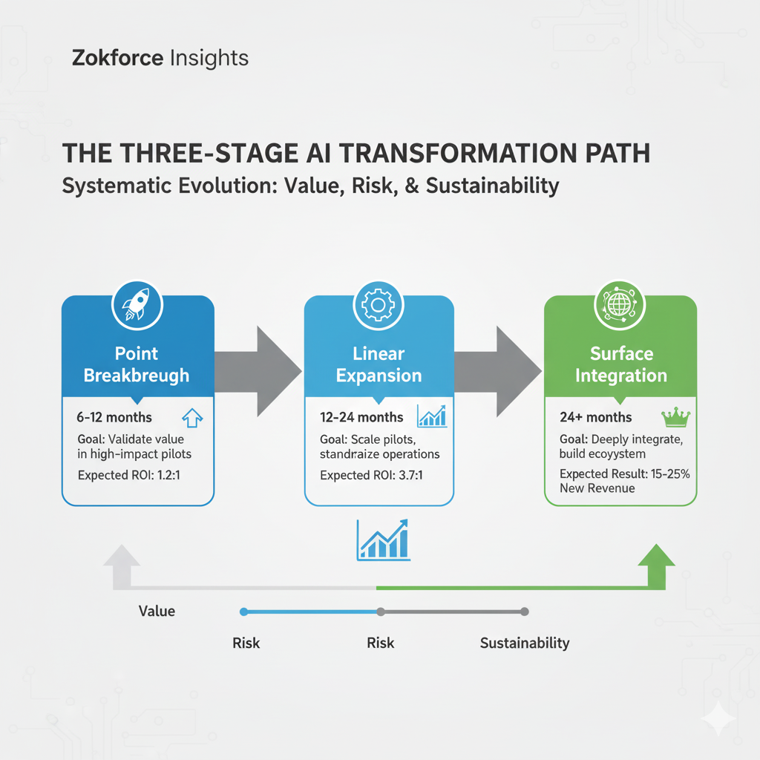
- Stage 1: Point Breakthrough (6-12 months):
  - Goal: Rapidly validate AI's business value in a high-impact, low-risk scenario.
  - Strategy: Use agile methods for quick validation (30-90 days) and build a minimal viable governance framework.
  - Expected ROI: 1.2:1, confirming technical feasibility and building organizational confidence.
- Stage 2: Linear Expansion (12-24 months):
  - Goal: Scale successful pilots across the organization by standardizing operations.
  - Strategy: Abstract pilot experiences into reusable templates and build a unified AI development platform.
  - Expected ROI: 3.7:1, achieving 40-60% cost reduction as AI covers 60-80% of core business.
- Stage 3: Surface Integration (24+ months):
  - Goal: Deeply integrate AI into core systems and build an open ecosystem to create sustainable competitive advantages.
  - Strategy: Become an AI capability provider, create new business models, and establish industry leadership.
  - Expected Results: New business revenue accounts for 15-25% of total income.

A Deeper Dive: Key Enablers of Modern AI Transformation
Two key trends are shaping the future of enterprise AI: the rise of Intelligent Agents and the strategic importance of AI Governance.

The Ascent of Intelligent Agent AI
The paradigm is shifting from passive AI tools to autonomous Intelligent Agents that can make decisions and execute multi-step tasks. Gartner predicts that by 2028,
33% of enterprise software will include agentic AI, up from less than 1% in 2024. These agents are already creating massive value:
- Supply Chain: One manufacturer improved inventory turnover by 35% and reduced stockouts by 60%.
- Cybersecurity: Agentic systems improve threat detection accuracy by 80% and reduce response time by 90%.

AI Governance: From Cost Center to Value Engine
Traditionally viewed as a compliance cost, robust AI governance is now a proven value driver. Enterprises with comprehensive governance frameworks achieve
30% higher ROI from their AI investments.
The value of governance is four-fold:
- Risk Avoidance: Prevents fines (up to 7% of global turnover), operational failures, and brand damage.
- Innovation Acceleration: Clear rules reduce uncertainty, allowing teams to innovate faster. Project cycles can be 40% shorter.
- Market Premium: Certified governance is a competitive advantage, commanding 15-25% higher pricing in B2B markets.
- Ecosystem Synergy: Strong governance builds the trust necessary for effective external partnerships and ecosystem growth.

Conclusion: Building the AI-Driven Future
Successful AI transformation is not about adopting the latest technology; it's about a strategic re-engineering of the enterprise to systematically create value. The key lies in finding a dynamic balance between technological innovation, governance responsibility, short-term wins, and long-term value.
By accurately assessing your maturity, prioritizing the right capabilities, and following a phased implementation path, your organization can bridge the value gap. The goal is a future where your enterprise does not just
use AI but becomes an intelligent, adaptive organization—capable of not only surviving but thriving in the coming era.

